**Assignment 01 – Say Hello to .git** 🚀

A screenshot or copy‑paste of the commands you ran plus their output

A short reflection (2‑3 sentences) answering:

“One thing that surprised me about what’s inside the .git folder was …”

Commit that reflection into the same repo before pushing (steps at the end).

Part A – Create & Commit (≈10 min)

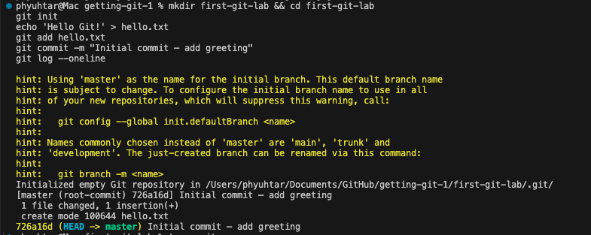

 Part B – Peek Inside .git (≈15 min)

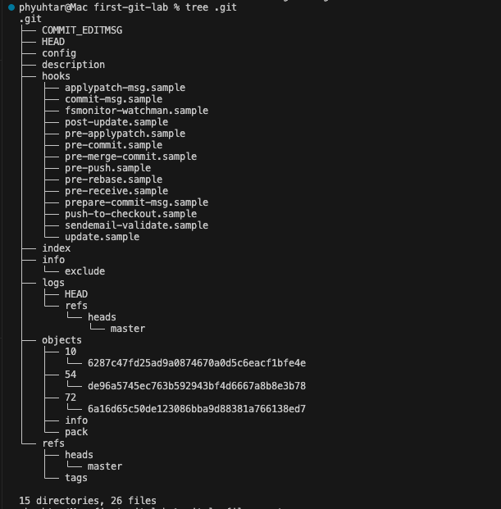

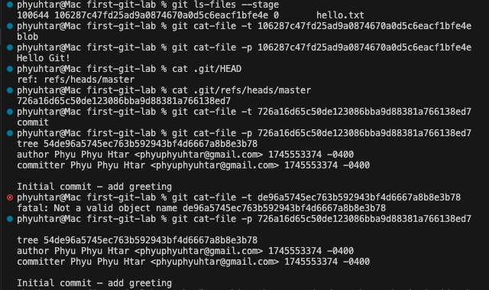

Part C – Reflect (≈5 min)



Part D – Push to GitHub (first‑time setup)

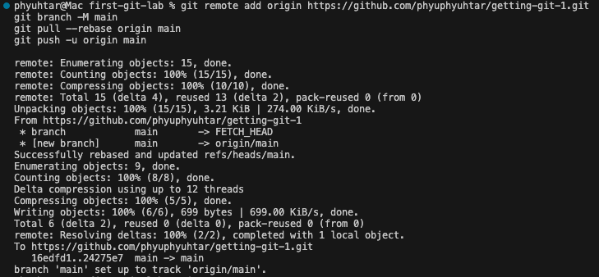

Extra credit (optional)

